

Ions produced by radiation carry a current

Demonstration
A radioactive source produces radiation that will ionise the air. The conducting air completes a circuit to charge an electroscope. Use the circuit to show the ionising effect of the radiation and present it as a means of detecting ionising radiation.

Apparatus and materials
- Power supply, EHT, 0–5 kV (with internal safety resistor)
- Metal plates with insulating handles, 2
- Gold leaf electroscope
- Hook for electroscope
- Retort stands and bosses, 2
- Connecting leads
- Sealed source of radium, 5 μC (if available) or sealed source of americium-241, 5 μC
- Holder for radioactive source (e.g. forceps)

Technical notes
A webcam or flexicam could be used to project an image of the gold leaf onto a screen. Alternatively, use a bright lamp to cast a shadow of the leaf onto a screen or wall.
The advantage of using an EHT is that it looks like an electric circuit – albeit a strange one. The electroscope plays the part of a very sensitive meter and the air between the plates is a component whose resistance changes.
Take care when using the electroscope not to make it all seem like a sleight of hand – especially when moving leads around.
Radium is a source of alpha, beta and gamma radiation. However, the beta and gamma radiation do not cause enough ionisation of the air to start a spark.

Safety
See guidance note on Managing radioactive materials in schools.
A school EHT supply is limited to a maximum current of 5 mA, which is regarded as safe. For use with a spark counter, the 50 MΩ safety resistor can be left in circuit, thus reducing the maximum shock current to less than 0.1 mA.
Although the school EHT supply is safe, shocks can make the demonstrator jump. It is therefore wise to see that there are no bare high-voltage conductors; use female 4 mm connectors, where required.
Read our health and safety statement.

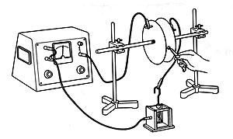

Procedure
Setting up
a Fix the two metal plates so that they are parallel to one another and about 1 cm apart.
b Connect one of the plates to the positive terminal of the EHT supply through the safety resistor.
c Connect the other plate to the leaf of the electroscope through the hook.
d Connect the case of the electroscope to the negative terminal of the EHT supply.
e Connect the negative terminal of the EHT supply to the earth terminal.
Getting a current to flow and charge the electroscope
f Set the EHT supply to about 3 kV and switch it on. The leaf of the electroscope will rise due to induced charges. Reset it by momentarily connecting the leaf to earth.
g Hold the sealed radium source beside the gap and point it between the plates. Watch what happens. The air in the gap is ionised and allows a charge to flow across the gap. This charges the leaf of the electroscope.
h Discharge the electroscope by momentarily connecting the leaf to earth. Try recharging it by holding the source at different angles to, and at different distances from, the plates.
Discharging the electroscope
You can also discharge the electroscope by ionising the air around it.
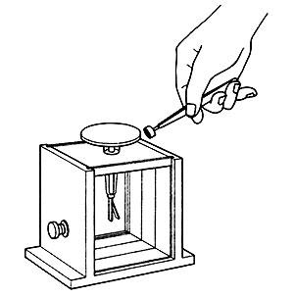
i Disconnect the electroscope from the supply but keep the base earthed. Replace the disc in the top of the electroscope and charge it using a flying lead from the positive terminal of the power supply (via the safety resistor).
j Point the sealed source over the top of the disc. This will ionise the air and allow the electroscope to discharge.
k Charge the electroscope again and try holding the sealed source at different angles to, and at different distances from, the disc.
The electroscope should discharge quickly to earth when the air above the disc is ionised. If it is discharging too slowly, bring an earthed metal plate up close to the disc of the electroscope.
Teaching notes
1 In the demonstration Ions produced by a flame carry a current (which can be found on the Practical Physics website), students met the idea that ionising the air allows the EHT to charge the electroscope. This demonstration uses the same idea, but now the ionisation is being caused by some invisible radiation coming from the sealed source.
2 As you bring the source towards the gap between the plates, point out that there is no flame and no obvious transfer of energy near the sealed source. Nevertheless, it must be producing ions in the gap, so it must be giving out some invisible radiation.
3 Use the term “ionising radiation” to describe what the source is giving out.
4 The circuit provides a visible means of detecting ionisation in the gap between the two plates. The electroscope provides the visibility, and the high voltage across the air gap is the means of catching ions. This is the same principle as a more convenient detector (the Geiger–Müller tube) and it provides students with a conceptual step towards its construction. This is developed further in The spark counter.
This experiment was safety-checked in May 2007
Related guidance notes
- Managing radioactive materials in schools
- Using an electroscope
- First models of the atom

